|  |  |
| --- | --- |
|  | Project – Question 1 |
|  |  |
|  | Christina Tatang 30003663  Programming III |

Contents

1. What data structures are you using? 2

2. Where are you using hashing techniques? 2

3. What sorting algorithm are you using how this is different from selection and bubble sort? 2

4. What search technique are you using? 2

5. What third party libraries are you using? 2

6. Where can I find the documentation for this? 2

7. A mock-up of the GUI. 2

8. What source control are you using? 3

9. What are your coding standards you are enforcing? 3

10. What tests are you going to run? 4

# What data structures are you using?

Double Linked List<T>. I will use double linked list because it’s easy implementation and efficient insertion and deletion. Unlike arrays, they are a dynamic data structure, resizable at run-time. Because we don’t know how the total elements that going to be use so we should use linked list to make it easier to develop. I’m going to use the list for the music.

## Where are you using hashing techniques?

I will use the hashing techniques in the password for the user information. There will be a username and the password to log in to the music player and I will hash the password and store it in the database. I use SHA256 hashing techniques. The reference for the hashing techniques can be found on MSDN or in this link <https://docs.microsoft.com/en-us/dotnet/api/system.security.cryptography.sha256?view=netframework-4.8>

# What sorting algorithm are you using how this is different from selection and bubble sort?

I will use bubble sort for my sorting algorithm because it is the simplest algorithm that works by repeatedly swapping adjacent elements if they are in wrong order. Bubble sort also very easy to understand and very easy to implement.

# What search technique are you using?

I will use a binary search. The binary search is a search technique that search from a sorted array by repeatedly dividing the search interval in half. Binary search is included as one of the fastest way to search an item and also a simple algorithm.

# What third party libraries are you using?

I will use MySQL Connector for NET development. So that the application will connect with the database using MySQL. In order to connect MySQL database to a C# application, MySQL provides a series of classes the MySQL Connector/NET. All the communication between a C# application and the MySQL server is routed through a MySQLConnection Object. This is the link for the download able MySQL Connector <https://dev.mysql.com/downloads/connector/net/>

# Where can I find the documentation for this?

The documentation for this project will be stored in the GitHub. This is the link for the GitHub repository <https://github.com/christinatatang/Project_AT3.git>

# A mock-up of the GUI.

This is the mock-up of the GUI for the music player form.

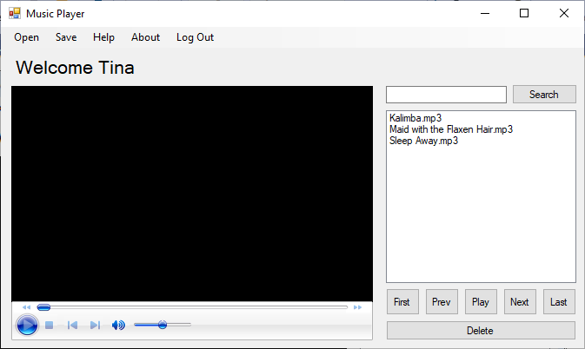

This is the mock-up of the GUI for the log in and create form. 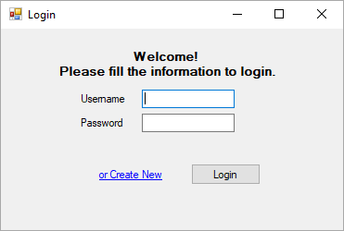

# What source control are you using?

I will use GitHub. The main benefits of using GitHub are it makes it easy to contribute to your open source projects because nearly every open-source project uses GitHub to manage their project. Moreover, it also keep track of your changes in your code across versions and make it easier to get documentation.

# What are your coding standards you are enforcing?

* Commenting and documentation
* Consistent indentation
* Avoid obvious comments
* Code grouping
* Consistent naming scheme
* DRY principle
* Avoid deep nesting
* Limit line length
* File and folder organization
* Consistent temporary names
* Capitalize special words
* Separation of code and data

The reference of the coding standard can be found in <https://code.tutsplus.com/tutorials/top-15-best-practices-for-writing-super-readable-code--net-8118>

# What tests are you going to run?

I will use a unit testing and functional testing. Unit testing consist in testing individual methods and functions of classes, components or modules used by your software, I use this one because it can be run very quickly and simply. Functional test focus on the business requirements of an application. They only verify the output of an action and do not check the intermediate states of the system when performing that action. Functional test would expected to get a specific value from the database as defined by the product requirements.